A Universal DFT Verification Environment: Filling the Gap between Function Simulation and ATE Test

Rui Huang
No.2, Science Institute South Rd.
Haidian District, Beijing, China 100190

Abstract-The DFT design has become more and more complex accompanying the increasing scale of SoC. How to verify DFT logic completely in simulation and how to supply test patterns to ATE test with high coverage are important for post-silicon debug and yield increase. While verification methodology is evolving, innovating and entering the UVM era, DFT verification needs to keep pace to leverage the advantages of UVM, and thereby to increase test reusability, extendibility and function coverage, etc. This paper presents a general UVM-based DFT verification environment, which can be used from modular DFT verification to SoC DFT verification, and it can generate functionally equivalent STIL test patterns for ATE test during SoC simulation. This paper also presents a method to model hierarchically networked DFT TDR at register abstract level in the UVM environment to allow test writers focus on test sequences without taking care of the details in TDR read and write operations.

I. Introduction
In DFT (Design For Testability) domain, the test patterns running on an ATE (Automatic Test Equipment) can be categorized into two types: scan related and non-scan related. The former can be generated using ATPG (Automatic Test Pattern Generation) tools, while the latter cannot. Like other function tests, these non-scan DFT function tests are normally created by design verification engineers using languages such as SystemVerilog or C++. However, ATEs need test patterns described by STIL (Standard Test Interface Language) or other test languages.
To fill the gap, there is usually a dedicated team to transfer function simulation to ATE test environment, or alternatively in-house automation flows are developed to enforce complex rules on test writing and register specification documentation, which are specific for a given environment and difficult to migrate.
This paper provides a universal and more efficient solution by introducing a UVM (Universal Verification Methodology) based DFT verification environment that naturally generates test patterns in STIL format during simulation and can be plugged into any UVM-based environment. This method applies to other formats that ATEs need.
For ultra-large-scale SoC (System on Chip), IEEE 1149 protocol alone cannot satisfy DFT design requirements, so IEEE 1687 and 1500 protocols are usually adopted to enable modular and hierarchical DFT test access, leading to challenges when writing test sequences at RAL (register abstract level), as different protocol TDRs (Test Data Register) are hierarchically located in a network connected via IEEE 1687. To access a TDR, one or more levels 1687 SIBs (Segment Insertion Bit) have to be set and the length of DR (Data Register) chain varies with SIB values. The author also comes up with a general way to model complex DFT test access network.

Structure of This Paper
This paper is divided into four parts. The first part is about how to build a UVM-based DFT verification environment that can generate STIL test patterns naturally. Then the second part will focus on the method of lifting DFT TDR to register abstract level. The third part answers how to verify that the generated STIL pattern works. The fourth part is the result discussion and conclusions.
In both of the first and second parts, the method we developed will be elaborated as follows: first, a general overview will be provided, and then the detailed implementation will be explained with reference to an example.

II. UVM-Based DFT Verification Environment

Idea Overview
The STIL test pattern describes test stimulus using vectors which specify pad toggle and measurement information (called STIL information hereinafter) in a time period.
A UVM test usually contains one or several sequences which are finally broken down into streams of UVM sequence items (a.k.a transactions) and passed to UVM drivers. UVM drivers are normally used for toggle and sample pads of DUT, meaning that they also contain the STIL information passing through. In fact, as to be demonstrated in this paper, the UVM drivers are the best supplier of STIL information.
With the precondition that any pad drive and sample are controlled by a UVM driver, which enforces no direct pad connection in the test bench, simply by collecting all STIL information from the drivers and then writing them out according to the time stamp of STIL information, we can obtain complete test vectors of a certain UVM test when the simulation finishes.
Thus, we can divide the pads of an SoC into the following types for DFT functional simulation:
- IEEE 1149.1 compliance on-chip TAP (Test Access Port). Hereinafter, it’s simply called JTAG (Joint Test Action Group) interface as show in Table I, which is the most important interface for DFT design. Please note that in Table I, read_not_write signal is not included in IEEE 1149.1, as it is an internal signal only used in this environment, for more description please refer to Section C.5.
- Clock pads, which are clocks that need to toggle in DFT functional simulation. See Section D for more description.
- Reset pads. All the reset related pads are categorized into this type.
- Other pads. Except for type 1) to 3) abovementioned, the remaining pads are categorized into this type. These pads may need to have initial value or be toggled once in a while in simulation. See Section E for more description.
In Figure 1, jtag_driver, clock_driver, reset_driver and pad_driver correspond to the above four pad types, respectively. The STIL generator collects STIL information from these drivers and writes them to a STIL pattern file.

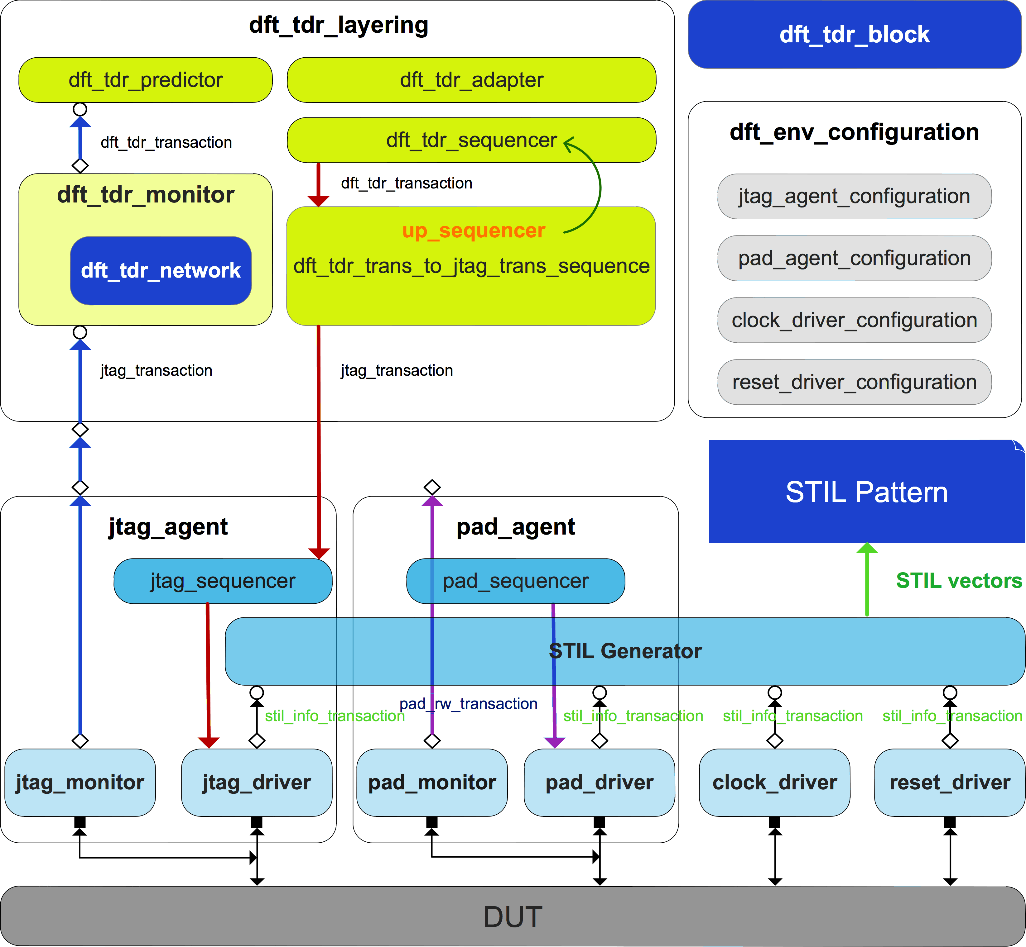
Figure 1. UVM-based DFT verification environment.

jtag_agent Implementation
In Figure 2, jtag_agent is composed of jtag_sequencer, jtag_monitor and jtag_driver, all of them configured through jtag_agent_configuration.

jtag_agent_configuration Class
Figure 3 shows properties and a key method (pad_info_init ()) of jtag_configuration class.
jtag_vi is virtual JTAG interface.
reg_block is TDR register model in RAL.
gen_stil_file is configuration knob to turn on STIL pattern generation during simulation.
stil_file_name is desired STIL pattern file name.
pad_name array stores the JTAG interface package name of an SoC and the pad_dir array indicates pads direction. STIL pattern files need this information to describe stimuli vectors.
DFT test must call pad_info_init () method before UVM main_phase objection and store it in a configuration database for drivers and STIL generator fetch.

Table I
jtag Interface Definition
JTAG Interface
Pad Direction | Pad Name
input | TCK
input | TMS
input | TRST_L
input | TDI
output | TDO
input | read_not_write

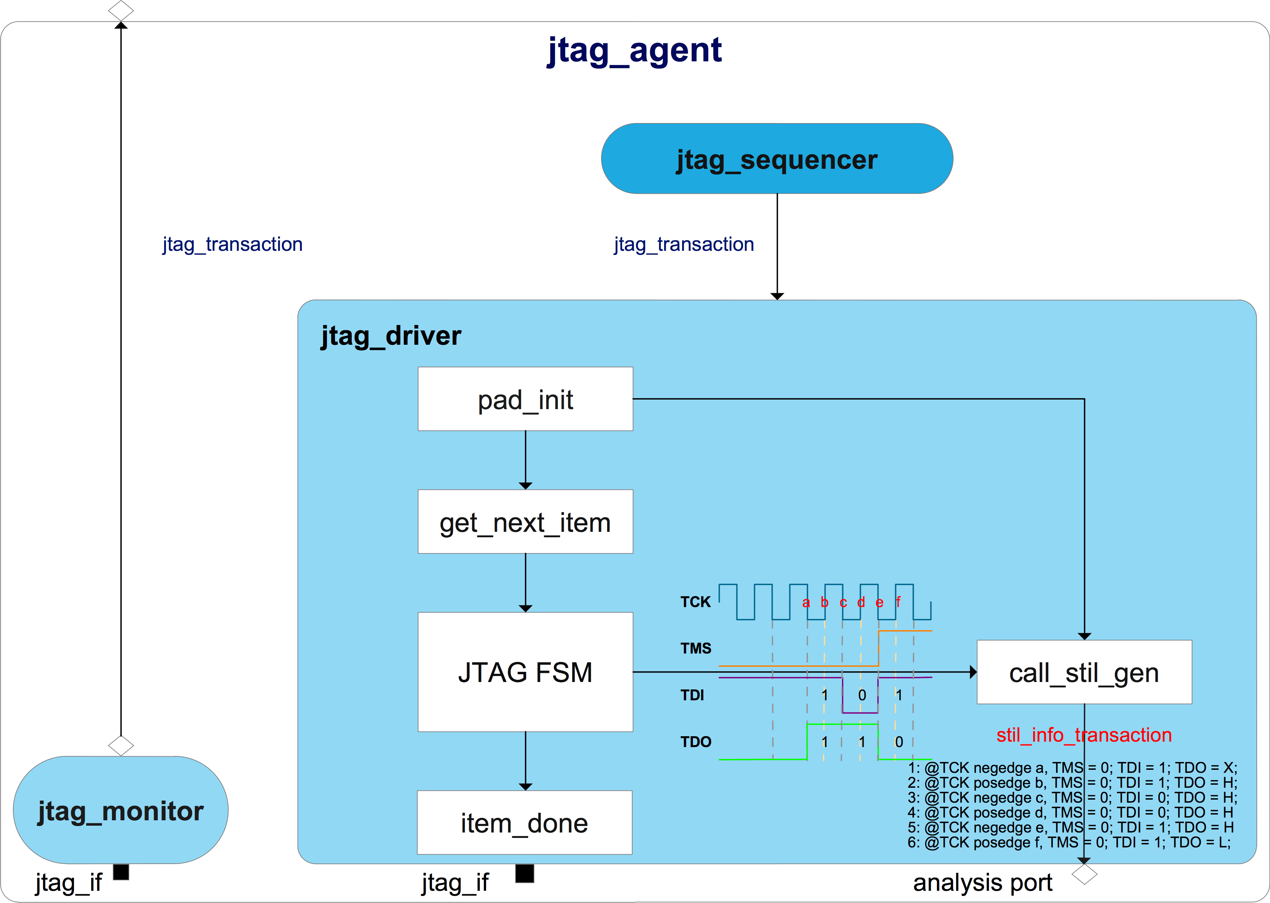
Figure 2. JTAG agent

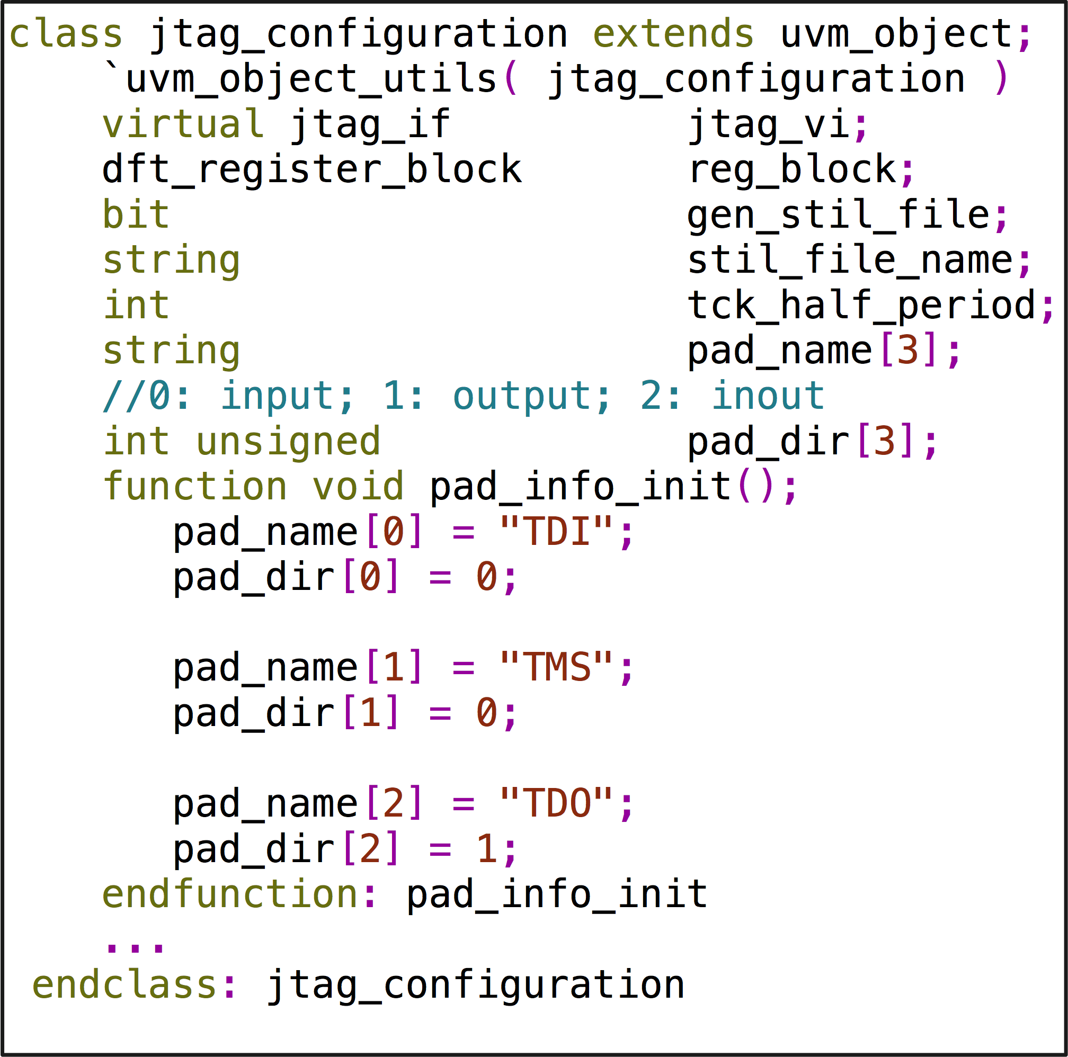
Figure 3. jtag_configuration properties and pad_info_int () method

jtag_transaction Class
Fig. 4 shows properties of jtag_transaction class.
o_ir is a dynamic array to store instruction operation code (a.k.a OPCODE) sending to DUT JTAG 1149.1 FSM Instruction Register (IR) and o_ir_length is its size.
o_dr is a dynamic array to store data sending to DUT’s IEEE 1149.1 compliance FSM Data Register (DR) and o_dr_length is its size.
tdo_dr_queue, tdo_ir_queue, tdi_dr_queue and tdi_ir_queue store data during shift IR or DR state monitoring by jtag_monitor.
chk_ir_tdo and chk_dr_tdo are flags to indicate jtag_driver whether to check TDO cycle-by-cycle during shift IR or DR state.
exp_tdo_dr_queue is golden data expecting DUT output during shift DR state, which is used by the driver to check TDO data on the fly.
exp_tdo_dr_mask_queue indicates which bit in exp_tdo_dr_queue need not to check.

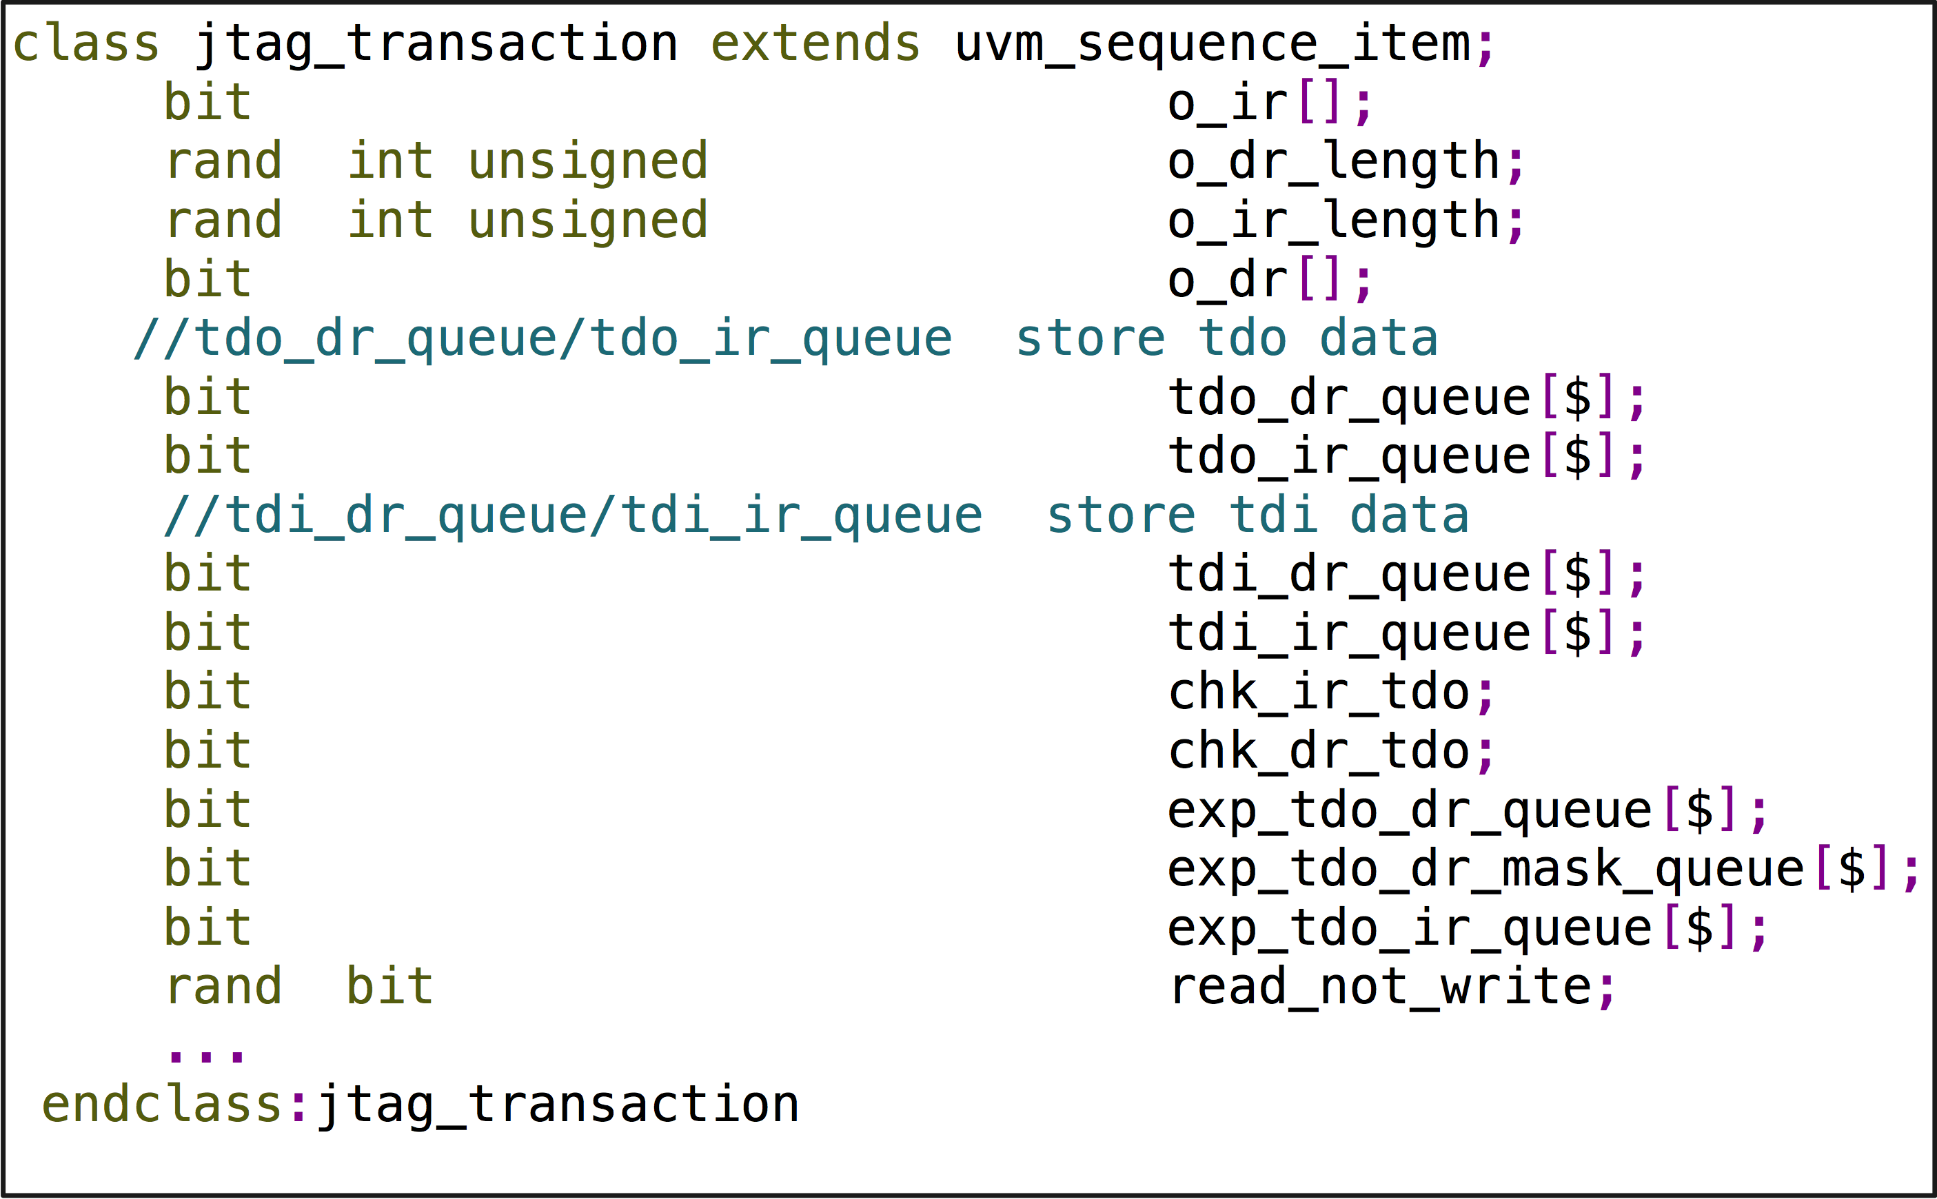
Figure 4. jtag_transaction properties

exp_tdo_ir_queue is golden data expecting DUT output during shift IR state, which is used by driver to check TDO data on the fly.
read_not_write is flag indicating jtag_monitor whether it’s a read or write operation for current transaction. Please see Section C.5 for more details.

JTAG interface
This paper categorizes pads of an SoC into 4 types which are driven by different drivers, so the JTAG interface shown in Table 1 is driven by a clock driver, reset driver, and JTAG driver as show in Fig.5.
Fig. 6 is jtag_if definition that does not contain all signals shown in Table I because of the categorization of pads. Others signals definition are included in clock_if and reset_if.

jtag_driver Class
IEEE 1149.1 protocol is implemented in jtag_driver, which fetches every jtag_transaction sequence item from jtag_sequencer, toggles the JTAG interface’s TDI and TMS, and samples TDO if chk_ir_tdo or chk_dr_tdo flag is on. exp_tdo_dr_queue and exp_tdo_ir_queue store the expected golden value, which also will be used as the golden measure information for TDO in a STIL pattern.
If the gen_stil_file knob is on, jtag_driver not only needs to toggle and sample pads, but also needs to convert the toggle and sample information to STIL information (handle by call_stil_gen () method), and then send to the STIL generator through an analysis port, which is an object of uvm_analysis_port class specialized with stil_info_transaction type.
In Fig. 2, let us suppose JTAG driver’s FSM is in shift DR state and is going to shift 3 bits 101 to DUT and sample TDO data during shift operation. The golden TDO data is 3 bits 110.
At TCK negative edge a, JTAG driver keeps TSM low to let DUT’s FSM stay in shift DR state and drives TDI high to send out the first bit out. call_stil_gen () method converts this information as show in line 1.
At TCK positive edge b, JTAG driver samples TDO and compares it with the golden value, which is 1 bit 1. call_stil_gen () method converts this information as show in line 2.
At TCK negative edge c, JTAG driver keeps TSM low to let DUT’s FSM stay in shift DR state and drives TDI low to send out the second bit out. call_stil_gen () method converts this information as show in line 3.
At TCK positive edge d, JTAG driver samples TDO and compares it with the golden value which is 1 bit 1. call_stil_gen () method converts this information as show in line 4.

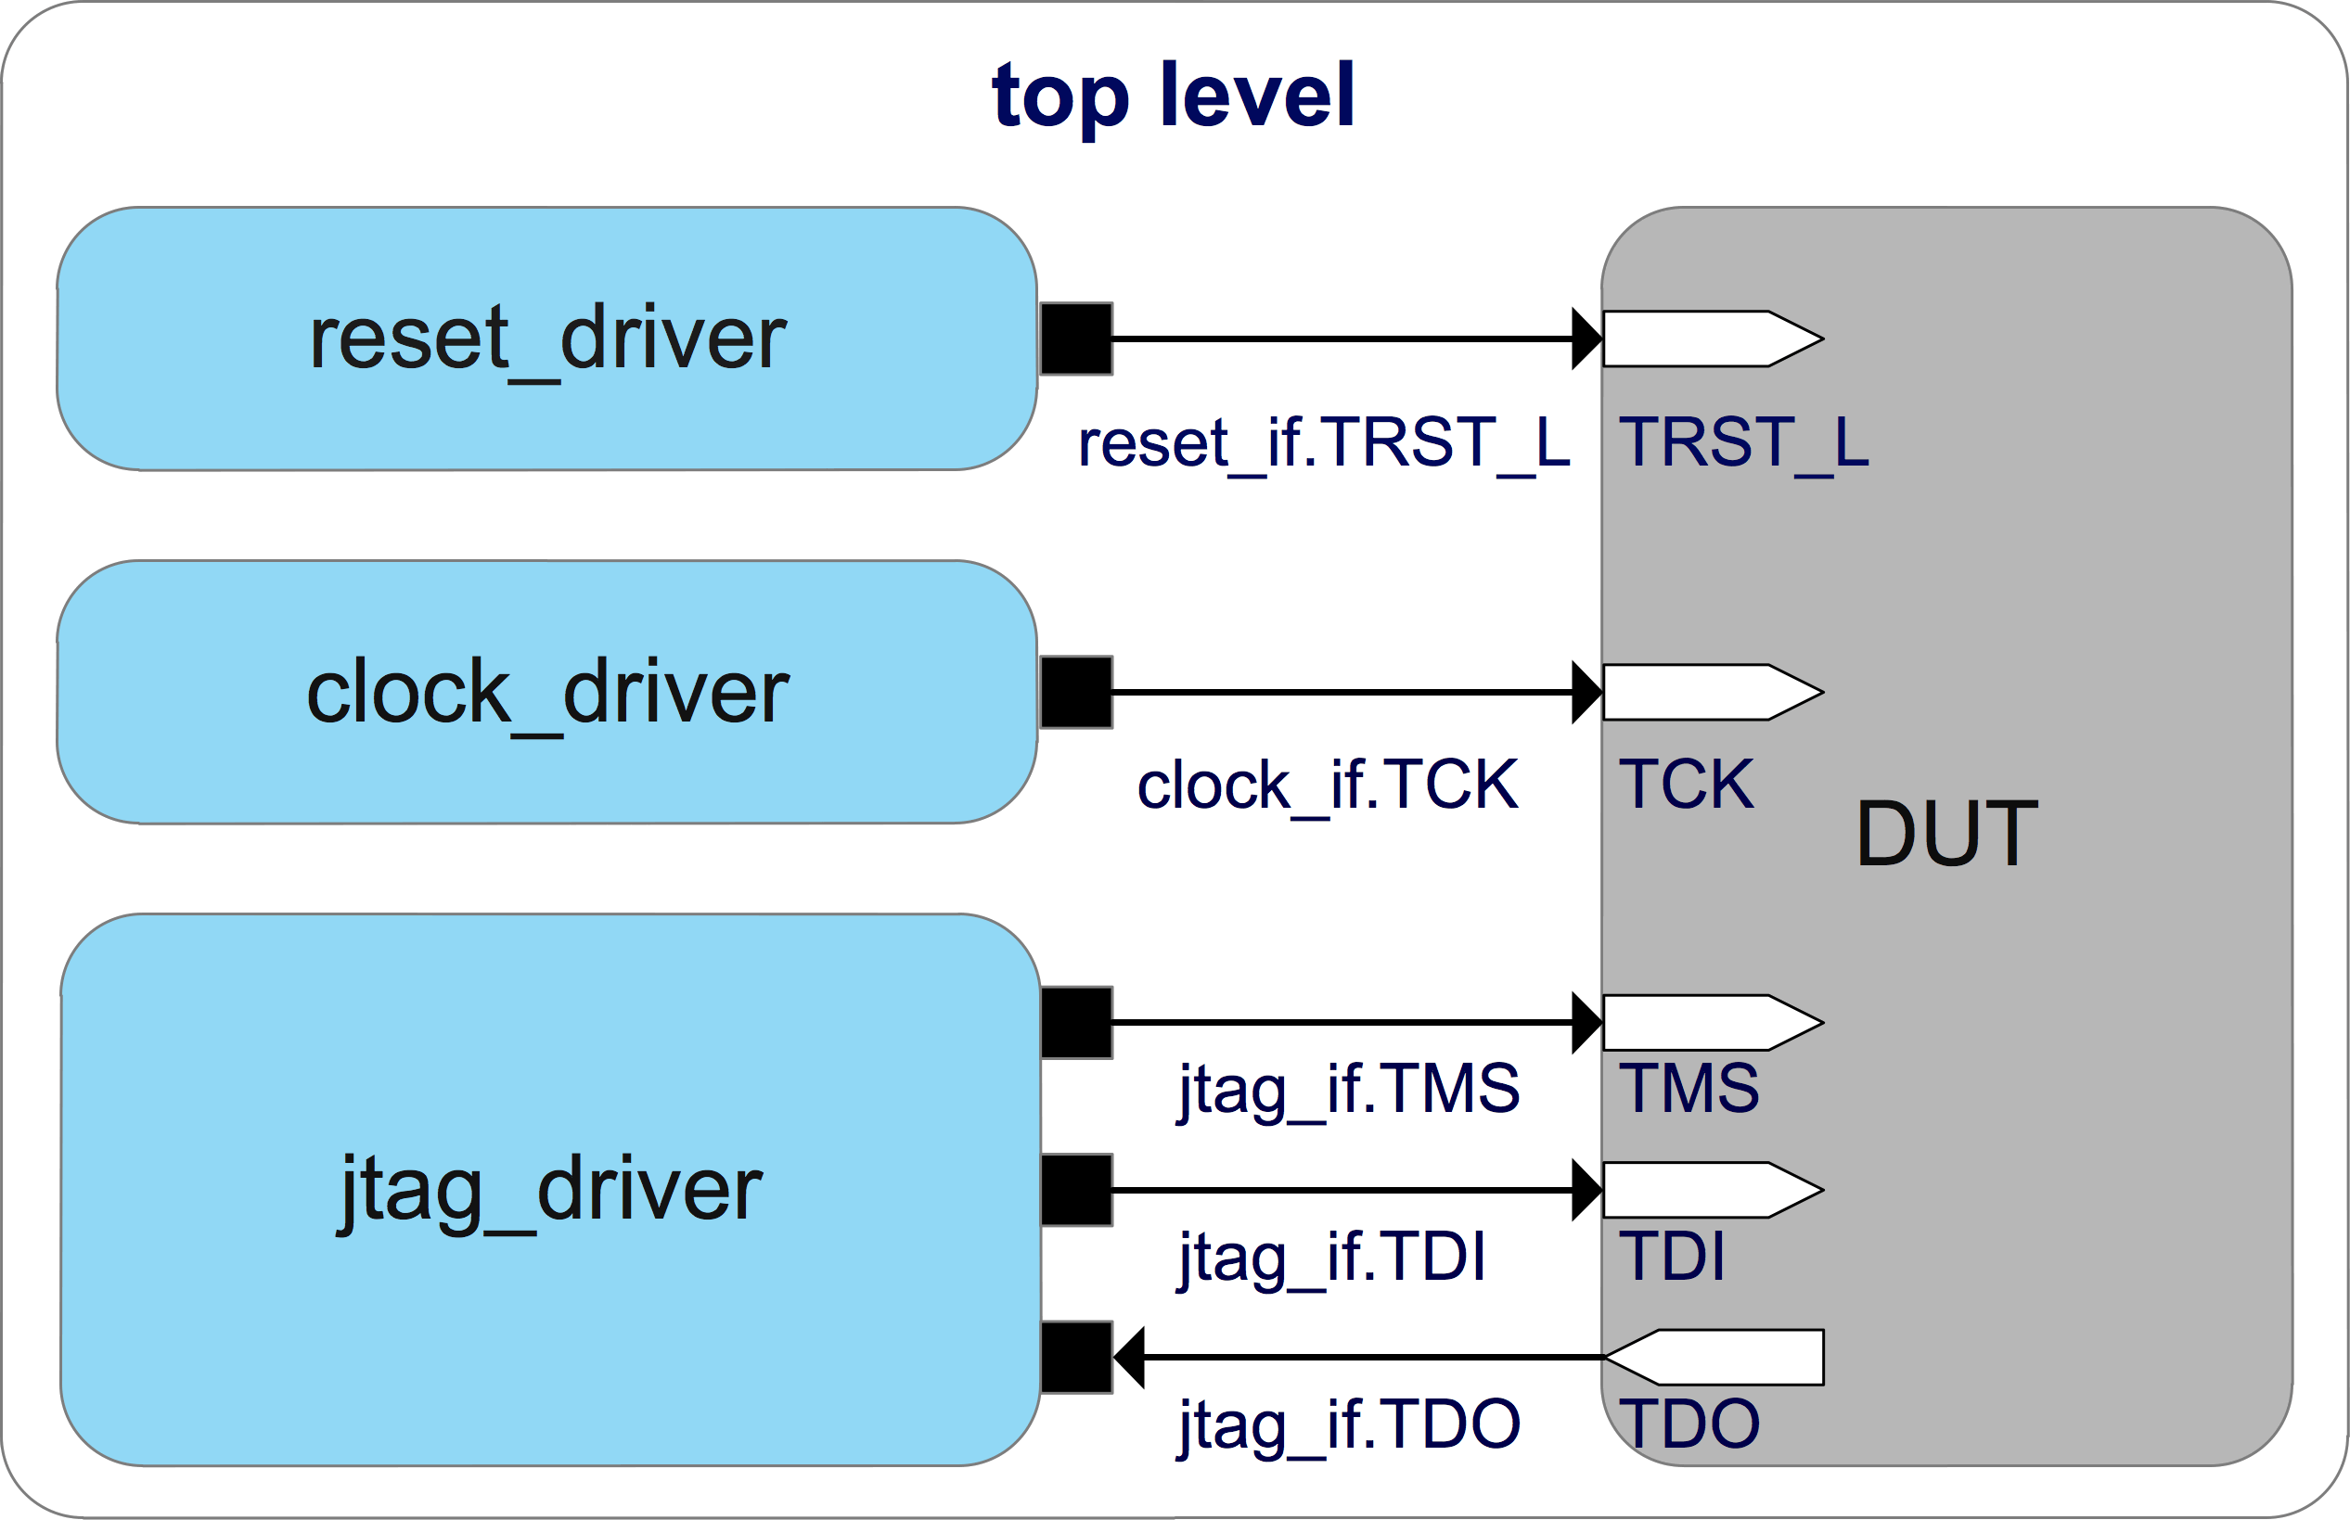
Figure 5. JTAG interface top-level connection

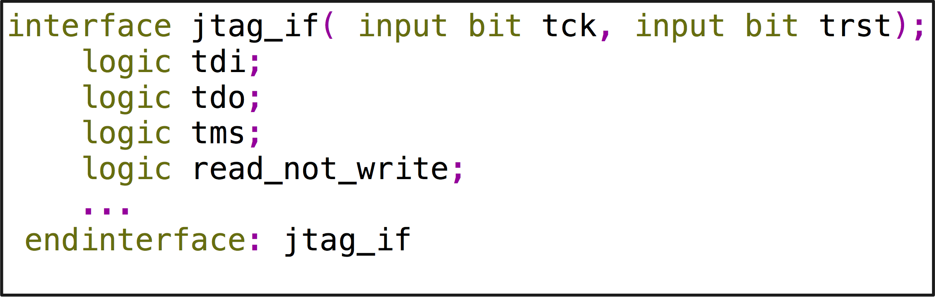
Figure 6. jtag_if properties definition
At TCK negative edge e, JTAG driver drives TSM low to let DUT’s FSM go to exit1 DR state and drives TDI high to send out the last bit out. call_stil_gen () method converts this information as show in line 5.
At TCK positive edge f, JTAG driver samples TDO and compares it with the golden value which is 1 bit 0. call_stil_gen () method converts this information as show in line 6.

jtag_monitor Class
There is a signal called read_not_write defined in JTAG interface shown in Table I, which is only used by jtag_monitor to indicate whether the current transaction is a write operation or read operation.
JTAG interface is a serial bus, while shifting TDI to a register, data stored in it is being shift out on TDO, so there is not a really so-called write or read operation.
Here, define write operation and read operation in concept for register abstract level convenience.
Read operation: data being shifted in a register is the same as the data stored in it.
Write operation: data being shifted in a register is different with the data stored in it.
jtag_monitor monitors JTAG interface activity, sampling TDI or TDO according to read_not_write signal, composing jtag_transaction sequence items and then passing them to dft_tdr_laying as shown in the blue arrows of Figure 1.

clock_driver Implementation
Fig. 7 is an example of how to toggle clocks in this DFT verification environment.
Suppose a DUT has two PLL reference clocks and a bypass clock needs to active during simulation, which are PLL1_REF, PLL2_REF, and BYPASS_CLK as show in Fig. 7.
clock_gen module in top level takes charge of these three clocks’ toggle. TCK of JTAG interface is generated by clock_driver.
If gen_stil_file knob is on, clock_driver needs to pass TCK toggle information to the call_stil_gen () method at the same time it drives TCK, and call_stil_gen needs to use the TCK toggle information as all active clocks’ toggle information and pass STIL information to the STIL generator.
Why do this? Does this imply all clocks run on the same frequency as TCK for an ATE test?
For an ATE test, PLL1_REF, PLL2_REF, and BYPASS_CLK toggle information in the STIL pattern can be regarded as a placeholder to let post silicon engineers be aware that these three clocks are reference clocks, so that they will not use the toggle information described in STIL patterns to driver reference clocks, but use clocks supplied by ATE with desired frequency.

pad_agent Implementation
The pad type 4 defined in Section B, can be subgrouped according to their function or interface protocol. Take memory pads, GPIO pads, and scan control pads as examples, each of them could be put in a separate subgroup.
Design pad interface and pad_rw_transaction as shown in Fig. 8 and Fig. 9.
Fig. 8 displays all properties of pad_rw_transaction class.
grp_num is used to indicate pad_dirver which group of pads to drive.
in_data_queue stores data being driven by pad_driver.
out_data_queue stores data being sampled by pad_driver.

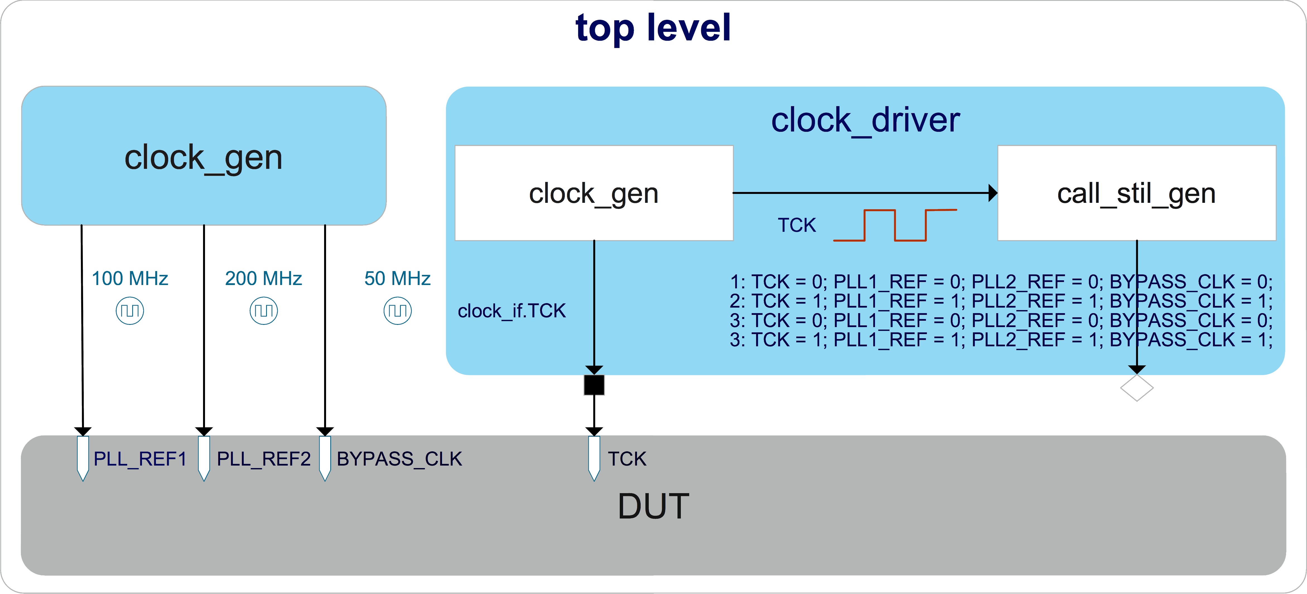
Figure 7. Clocks top-level connection

inout_data_queue stores data being driven or sampled by pad_driver. An unknown bit in the queue indicates pad_driver the corresponding pad is in output mode and it will write the sampled value into the same location.
exp_out_data_queue and exp_inout_data_queue stores golden value to let pad_driver check on the fly and also the information for STIL pattern to measure pad value during a time period converting by call_stil_gen function.
Please note these queue types should be logic instead of bit to store four state values.
In Fig. 9, pad_init () method will initialize all groups pads in turn at the beginning of run_phase task, and call_stil_gen () method will convert this information to STIL information and write to STIL generation through the analysis port.

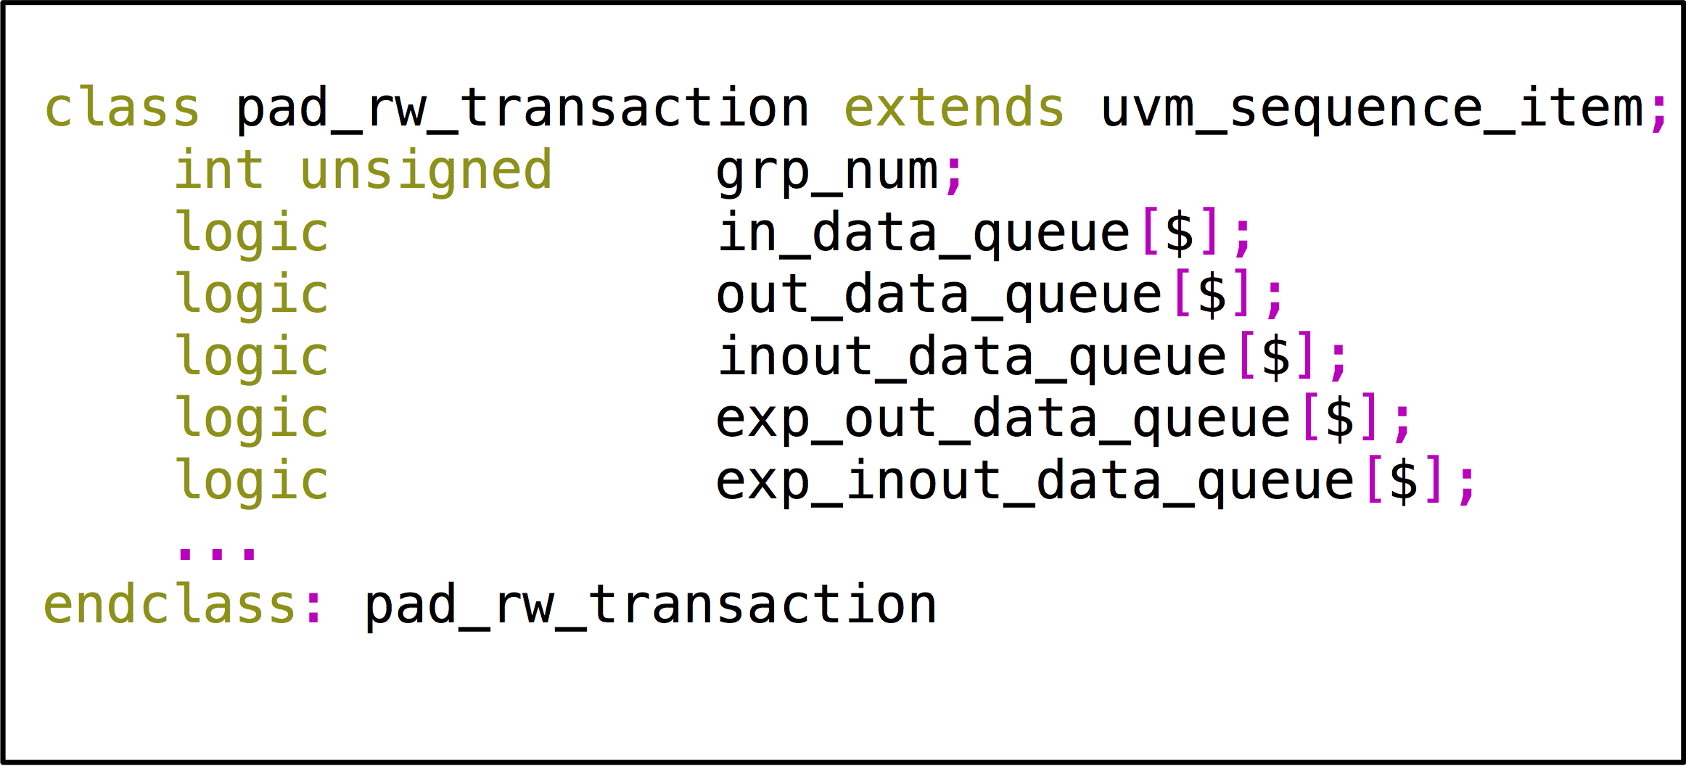
Figure 8. pad_rw_transaction properties definition

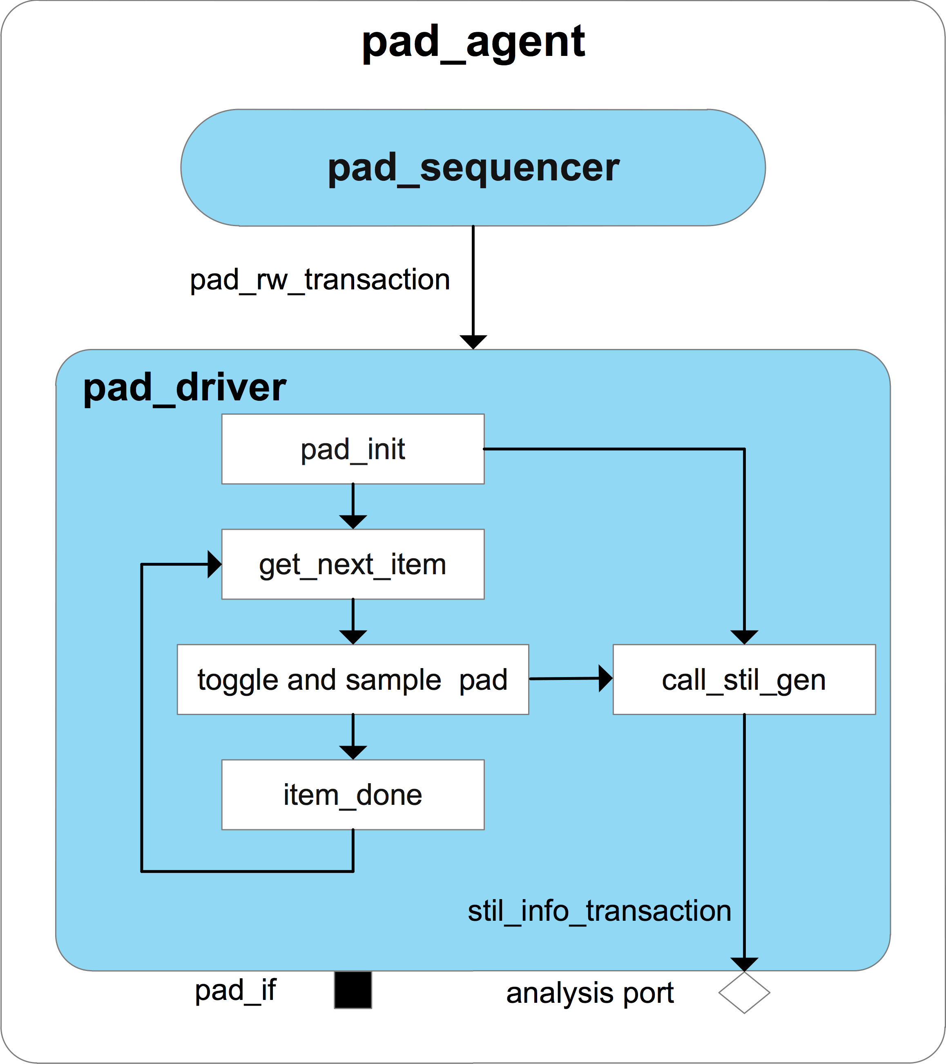
Figure 9. pad_agent

pad_agent_configuration Class
Fig. 10 is an example of pad_configuration class, which has two subgroups of pad.
UVM test needs to initialize every group’s package name by calling the pad_info_init () method before the main phase objection and stores it in configuration database for pad_driver and STIL generator fetch.

reset_driver Class
In Fig. 11, reset_driver drives all resets signals defined in reset interface.

stil_generator Class
The stil_generator, which extends from uvm_subscriber class specialized with stil_info_transaction type, has four analysis exports to connect with clock_driver, reset_driver, pad_driver, and jtag_driver’s analysis port separately. Since the uvm_subscriber class has only one built-in analysis export, the uvm_analysis_imp_decl macro needs to be used to declare analysis imp export and its associated write () method for the remaining analysis export [1].

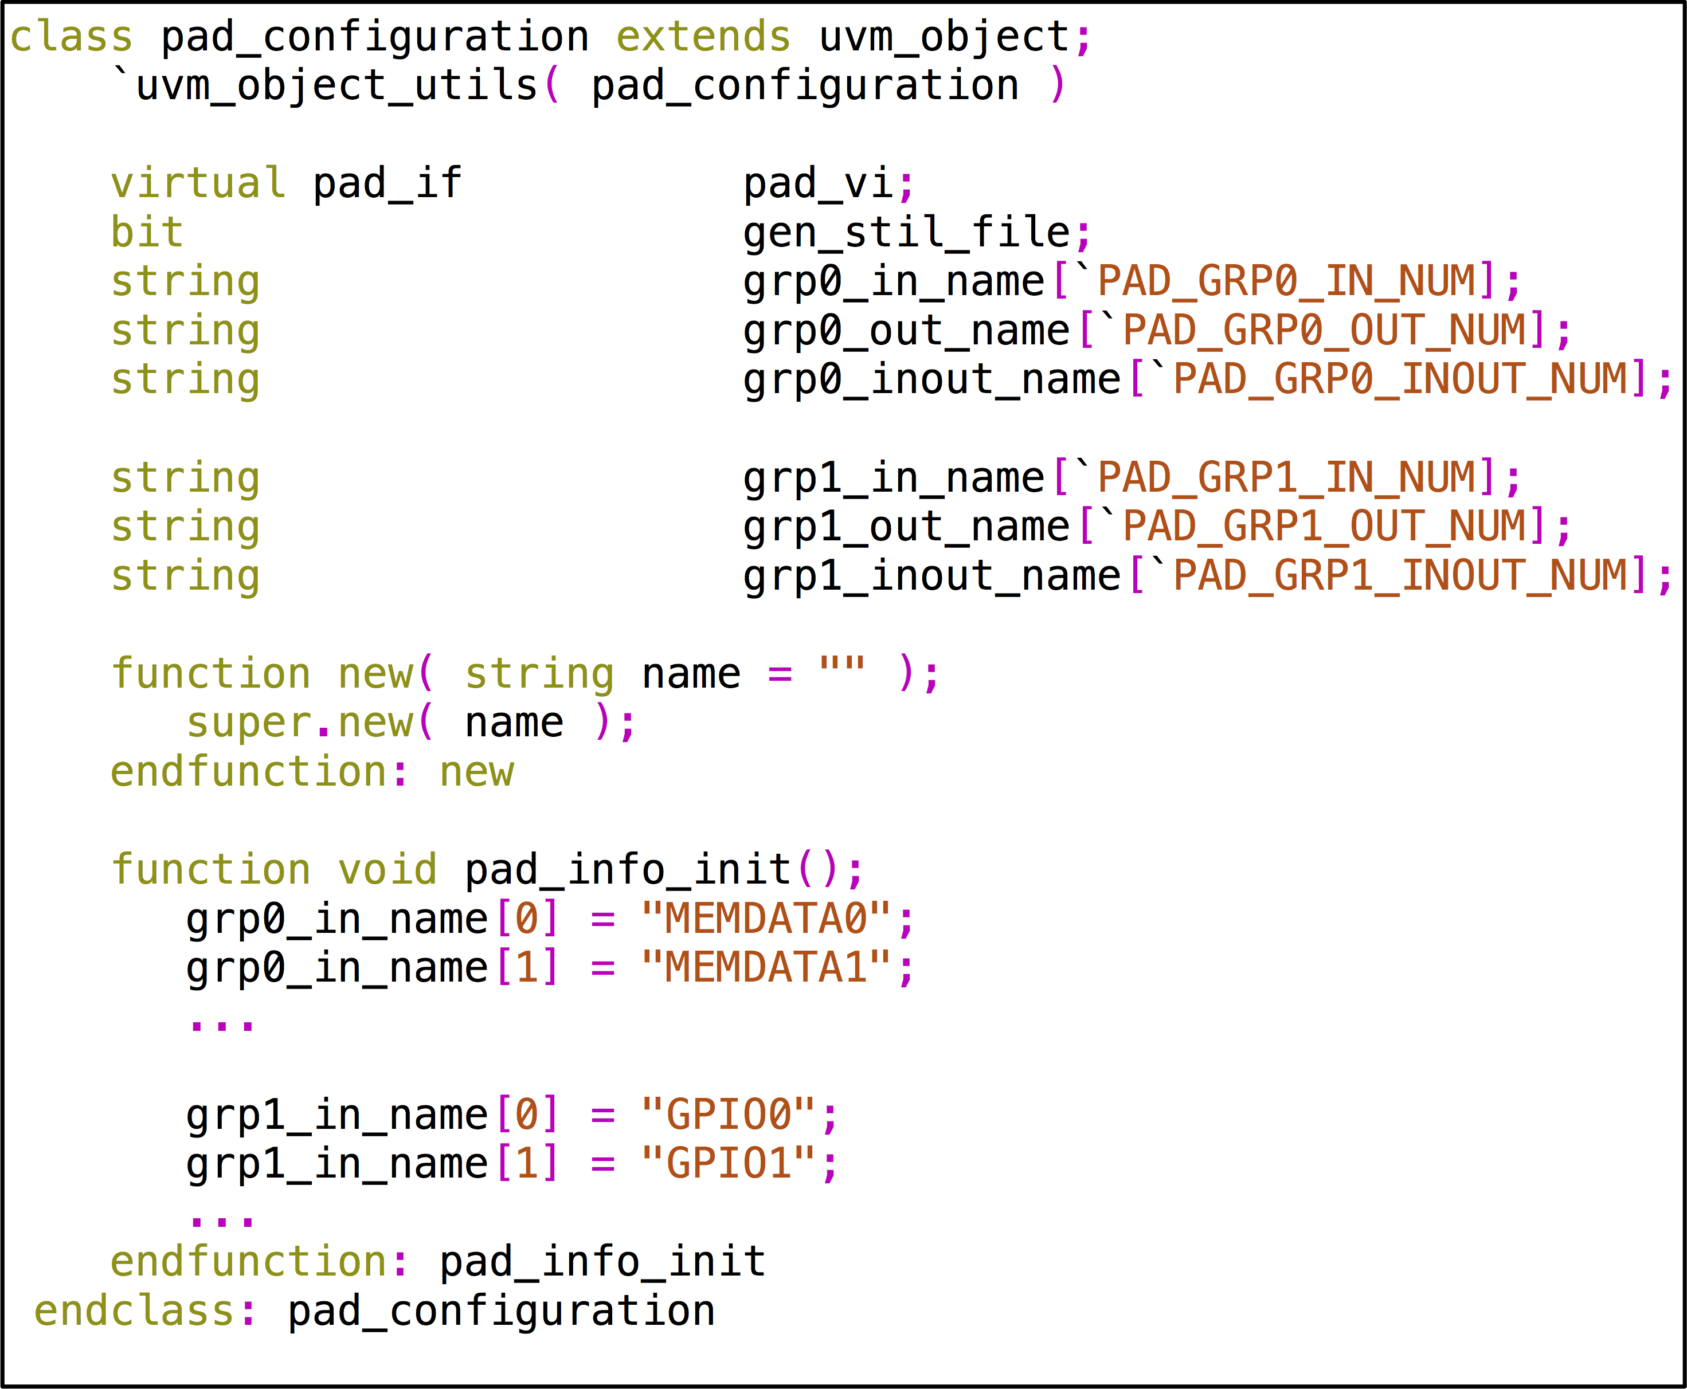
Figure 10. pad_configuration properties definition example

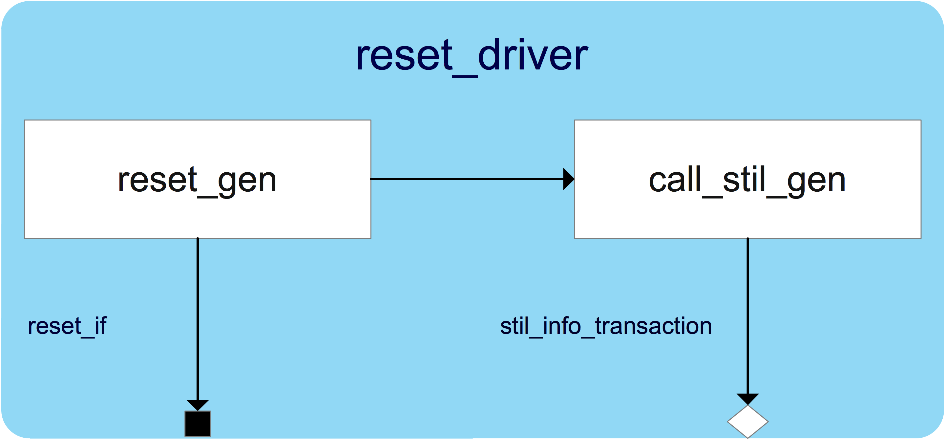
Figure 11. reset_driver
stil_info_transaction is defined in Figure 12. stil_info is pads toggle and measure information and comment info is the comment going to be printed out with the stil_info.
In Figure 13, each driver’s analysis port has its corresponding write () method, a semaphore which has only one key and a group of ping-pong buffers which have two variables, called ping_data_rdy and pong_data_rdy, to indicate ping-pong buffer status.
The stil_info_transaction written through a driver’s analysis port is stored in a ping-pong buffer group, each buffer stores one stil_info_transaction.

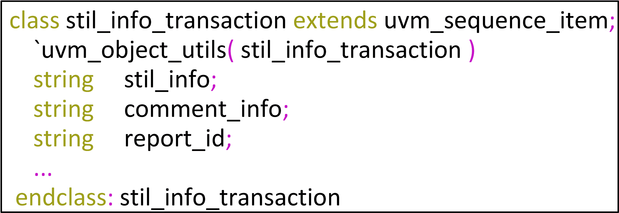
Figure 12. stil_info_transaction

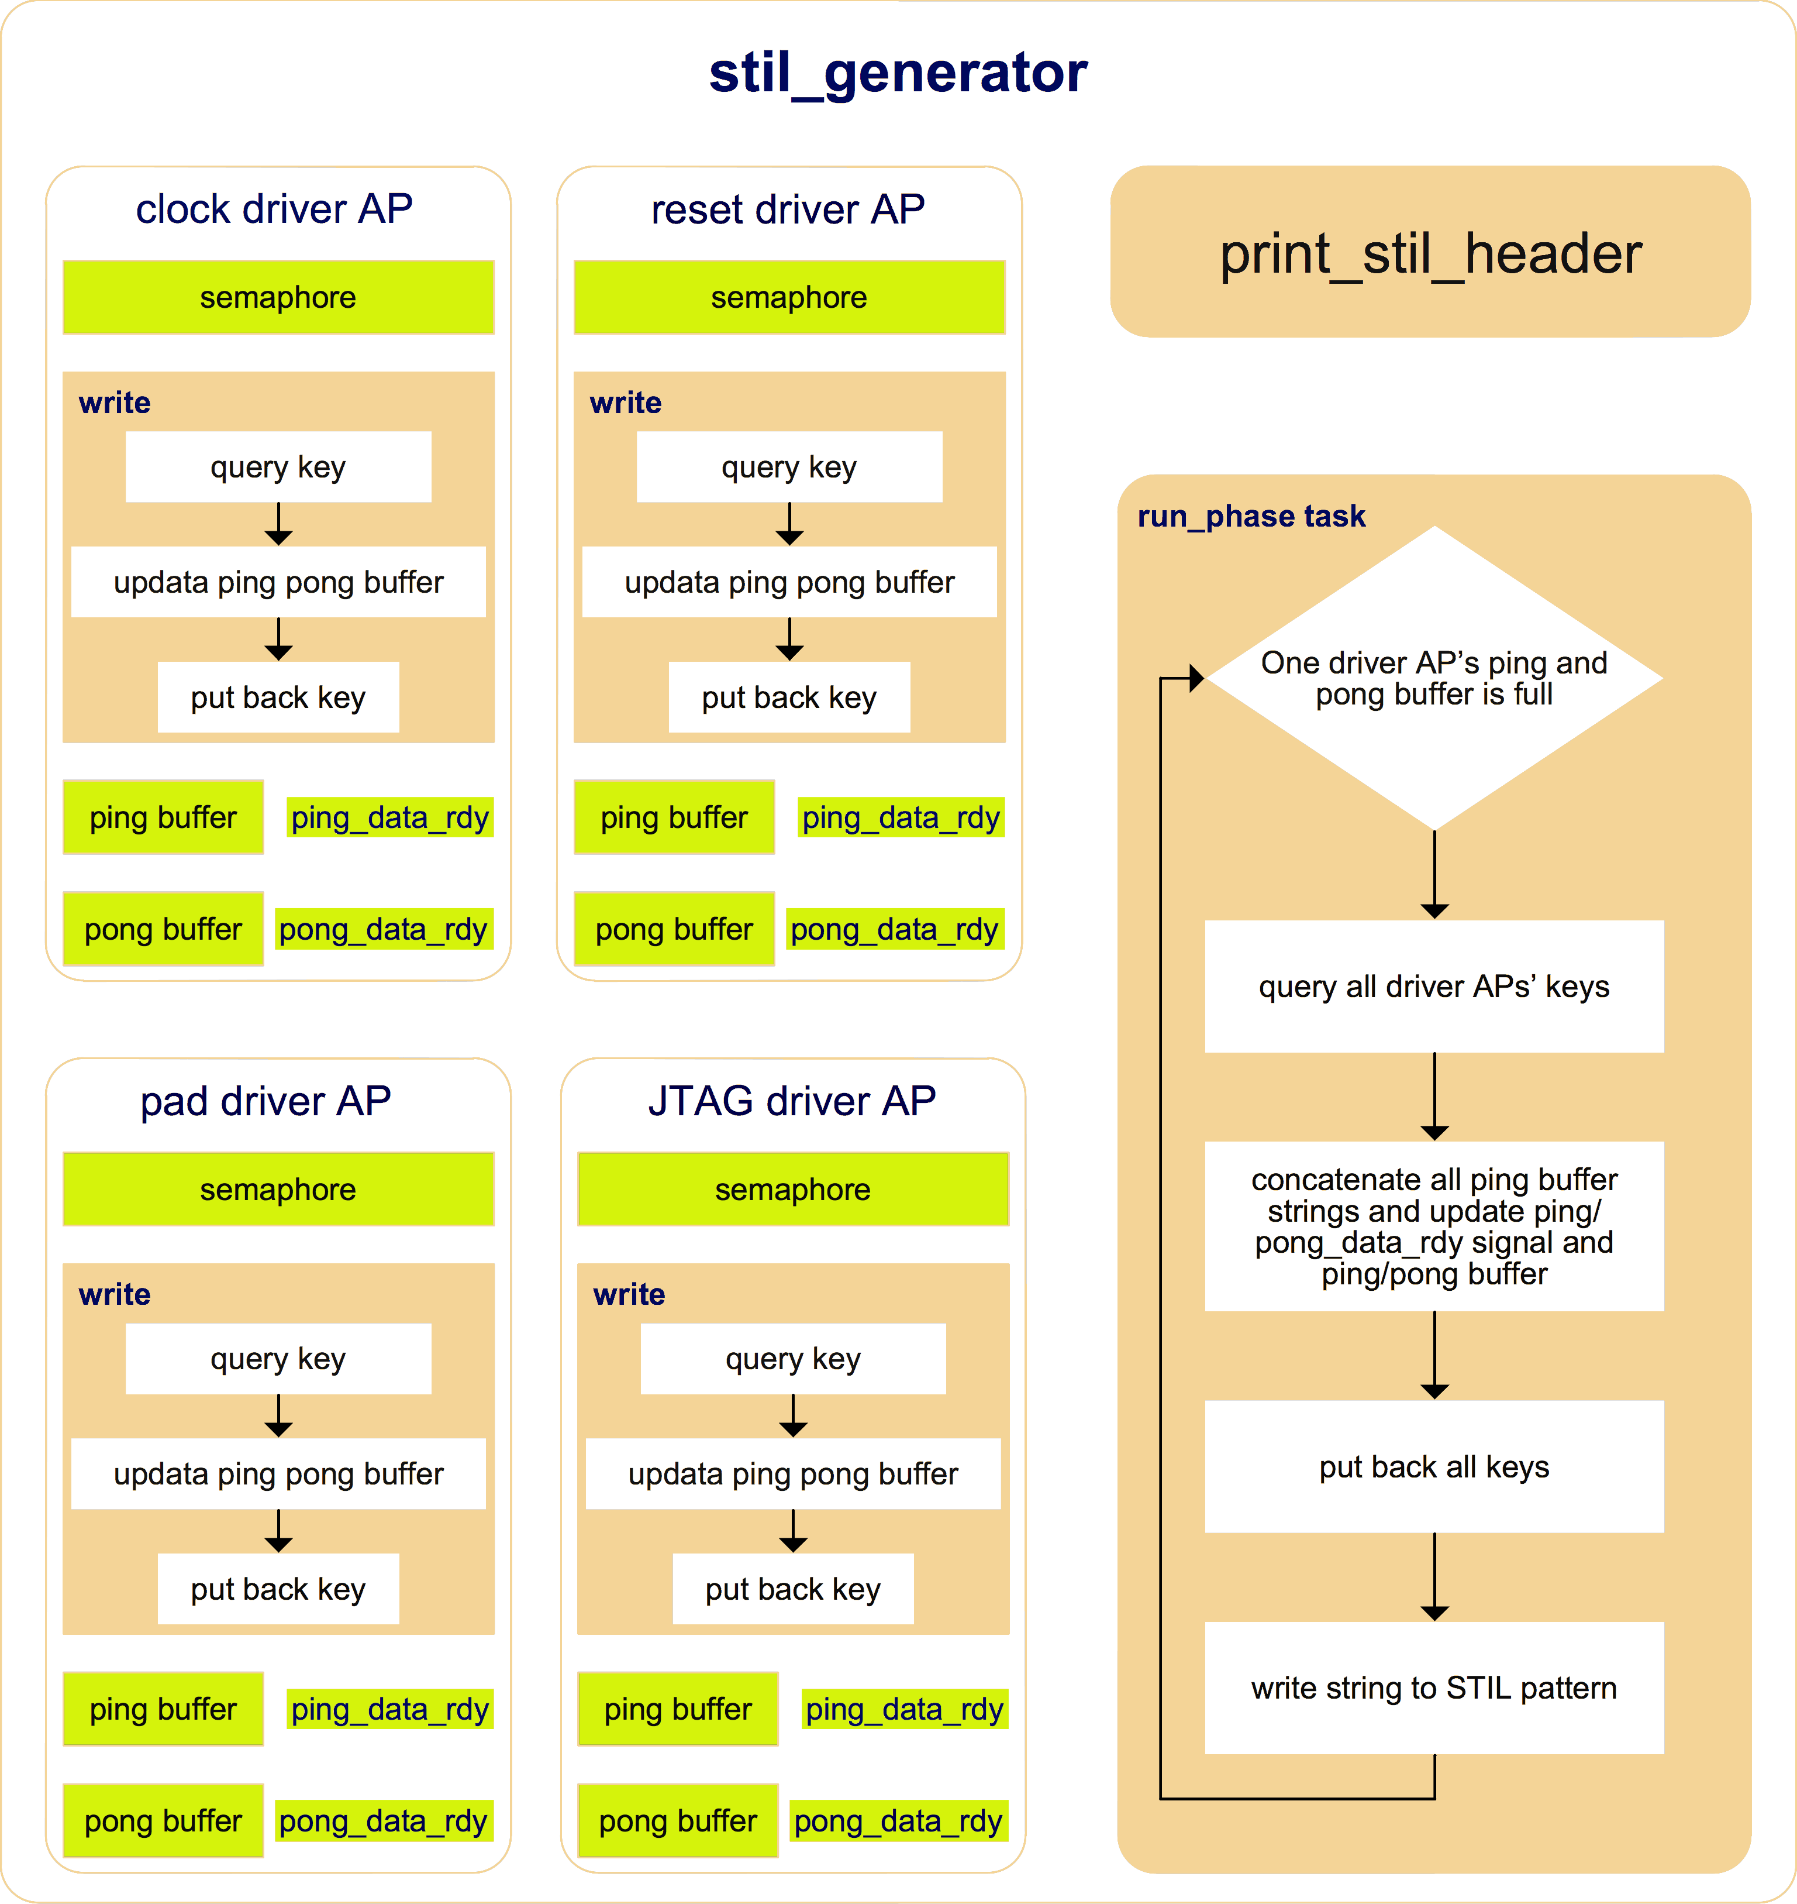
Figure 13. STIL generator
The stil_generator needs to collect all stil_info_transaction coming from the same simulation time slot, to concatenate stil_info of every stil_info_transaction, and to write them out as a single test vector. To make sure stil_generator does not miss any stil_info_transaction from the same time slot, it has to suspend the run task in stil_generator until all other run tasks finish. However, in UVM, because all uvm_component run tasks are executed in parallel and the stil_generator itself is an uvm_component, there is no easy way to schedule the simulation events in the stil_generator run task to be executed after all other drivers’ run task events finish.
To resolve this issue, a group of ping-pong buffers is introduced. The write () method always writes first the ping buffer and then the pong buffer, so the ping data and pong data come at different simulation time slots. Once a group of ping-pong buffers is full, which indicates the simulation has already moved forward, it will be the right time to collect all ping buffer data and write them out.
The run_phase task of stil_generator, as shown in Figure 13, always checks if a driver’s ping-pong buffer group is full. If the result is true, it will query each key of the semaphore belonging to the corresponding driver. Once it gets all the keys, it will then fetch all ping buffer data, update the ping-pong buffer groups (if both ping and pong buffers are empty, do nothing; if the ping buffer is full and pong buffer is empty, clear ping_data_rdy; if both ping and pong buffers are full, copy the pong buffer data to the ping buffer and clear pong_data_rdy), and put back all keys and write a test vector to STIL pattern.

III. DFT TDR Abstraction

Idea Overview
For ultra-large-scale SoC, usually there is a group of TDRs, which are either IEEE 1500 or IEEE 1149.1 compliance, being used to configure the DFT design of a tile or a large design block. The TDR groups among different tiles are chained together using IEEE 1687 protocol. Figure 14 is an example of DFT TDR access network.
It is necessary to level up TDR access in RAL, so as to make it easy to migrate UVM tests developing from this UVM-based DFT verification environment among verification environments and tests from block to system levels. By doing this test writers can focus on test sequences as such, rather than the complex operation of accessing every TDR hierarchically located in the network.
For non-UVM-based environment, the normal way is to define a base class according to its protocol (for example, to define an IEEE1500 TDR base class and an IEEE 1149 TDR base class) and wrap up a TDR access operation inside its extension. When DFT access network changes, the wrapped-up access operation in each TDR class has to be updated accordingly. Such work is usually time-consuming. However, the method of modelling DFT TDR in UVM-based environment is rarely seen in literature to the author’s knowledge.
This paper presents a neat and easy maintainance way to abstract TDR in UVM-based environment, as shown in Fig. 15.

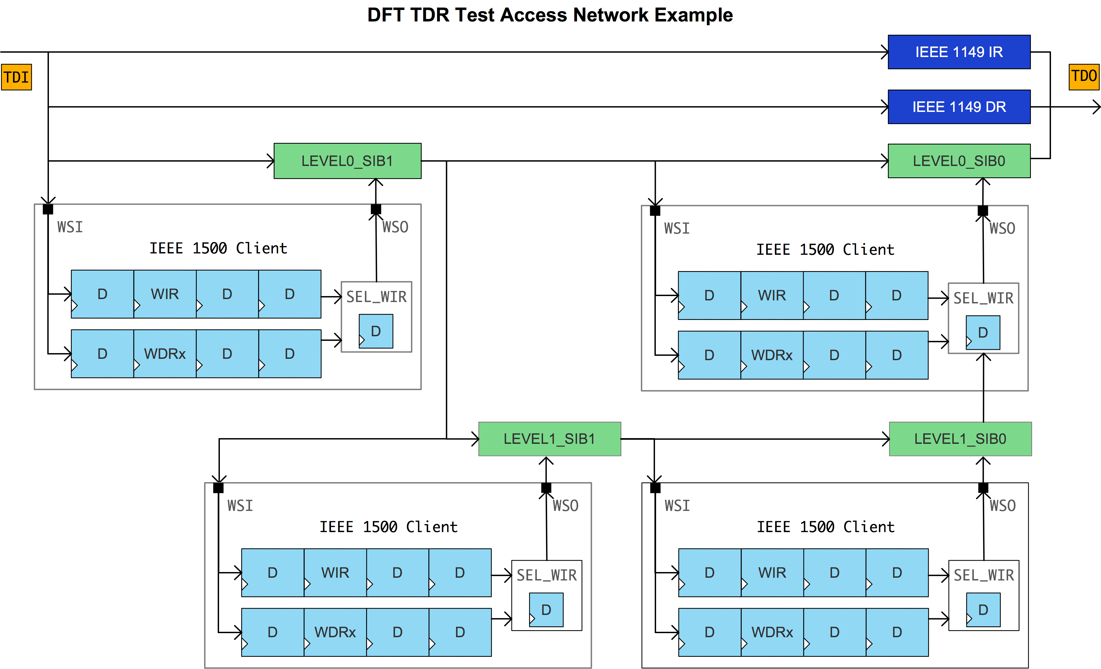
Figure 14. DFT TDR access network example

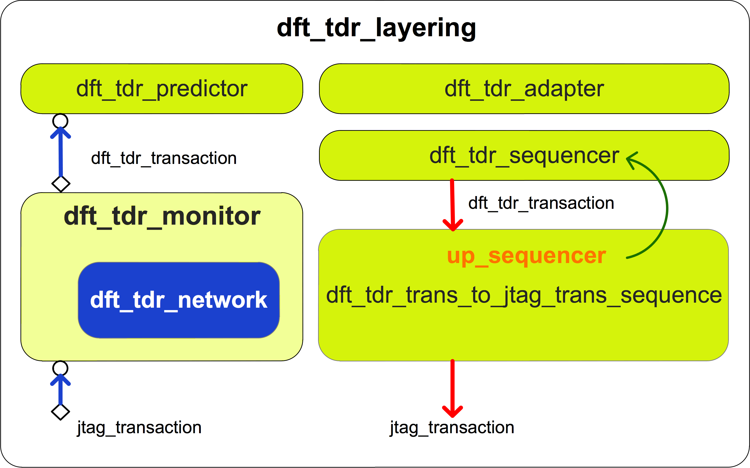
Figure 15. dft_tdr_layering

We can encode a TDR’s location information into its address shown in Figure 16 and model an equivalent TDR access network named as dft_tdr_network in dft_tdr_monitor.
In Figure 1, the reg2bus direction is shown in red lines, where dft_tdr_trans_to_jtag_trans_sequence fetches dft_tdr_transactions, unpacks address, decodes SIB code, and then generates jtag_transactions to jtag_sequencer [2]. For the bus2reg direction shown in blue lines, dft_tdr_network maintains network status using jtag_transactions from jtag_monitor. When sib_node values hit SIB code in dft_tdr_block, dft_tdr_monitor writes a dft_tdr_transaction to dft_tdr_predictor.
In this way, the TDR class definition is very neat, and only needs to declare each bit field. Figure 18 is an example of a TDR class. When TDR access network changes, we only need to update dft_tdr_network and dft_tdr_trans_to_jtag_trans_sequence, while all TDR class definitions don’t need any update which can save a lot of test environment setup time.

DFT TDR Access Network Modelling
In DFT TDR access network, a SIB bit and a TDR bit can be modelled as Figure 17.
out_update () method is to model the active clock edge triggering the shift register bit during shift operation and value_update () method is to model the active clock edge triggering the update register bit during update operation.
dft_tdr_network usese sib_node and reg_node to construct an equivalent network as DUT.
In Figure 14, it only needs to model each 1500 client’s IR and a WDR whose length is dynamic, which can calculate from jtag_transaction coming from jtag_monitor and current network chain length. It need not actually model every TDR, because each time only a TDR can be configured in a 1500 client.

DFT TDR Class Definition
DFT TDR class definition is similar to other function registers, which extend from uvm_reg class. A bypass TDR which has only one bit field is defined as Figure 18.

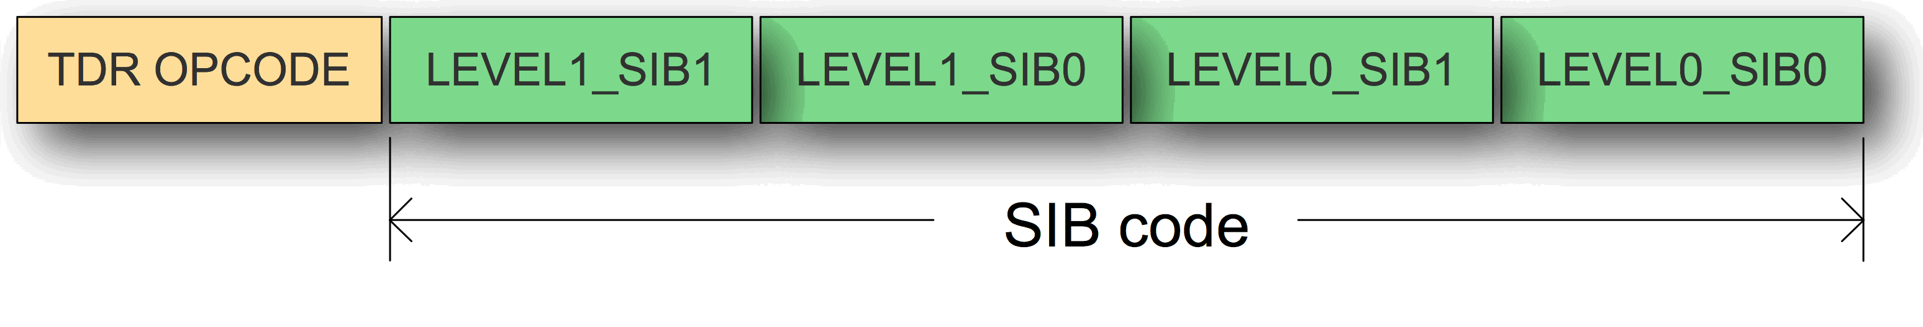
Figure 16. Address encode
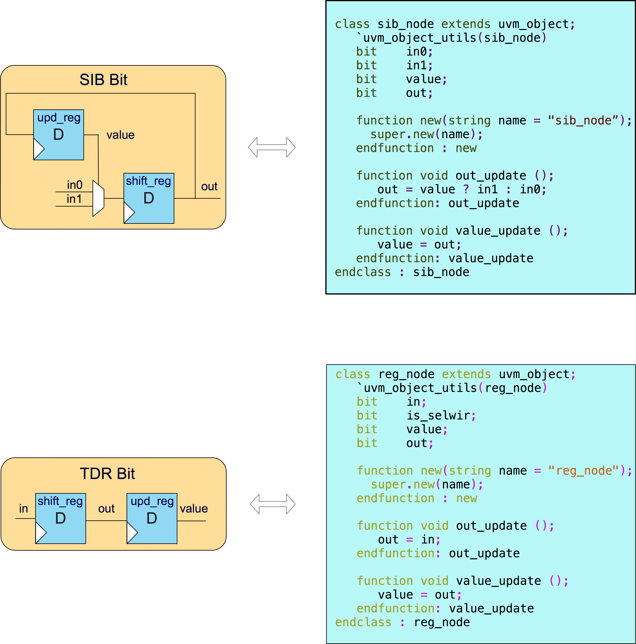
Figure 17. Network element model

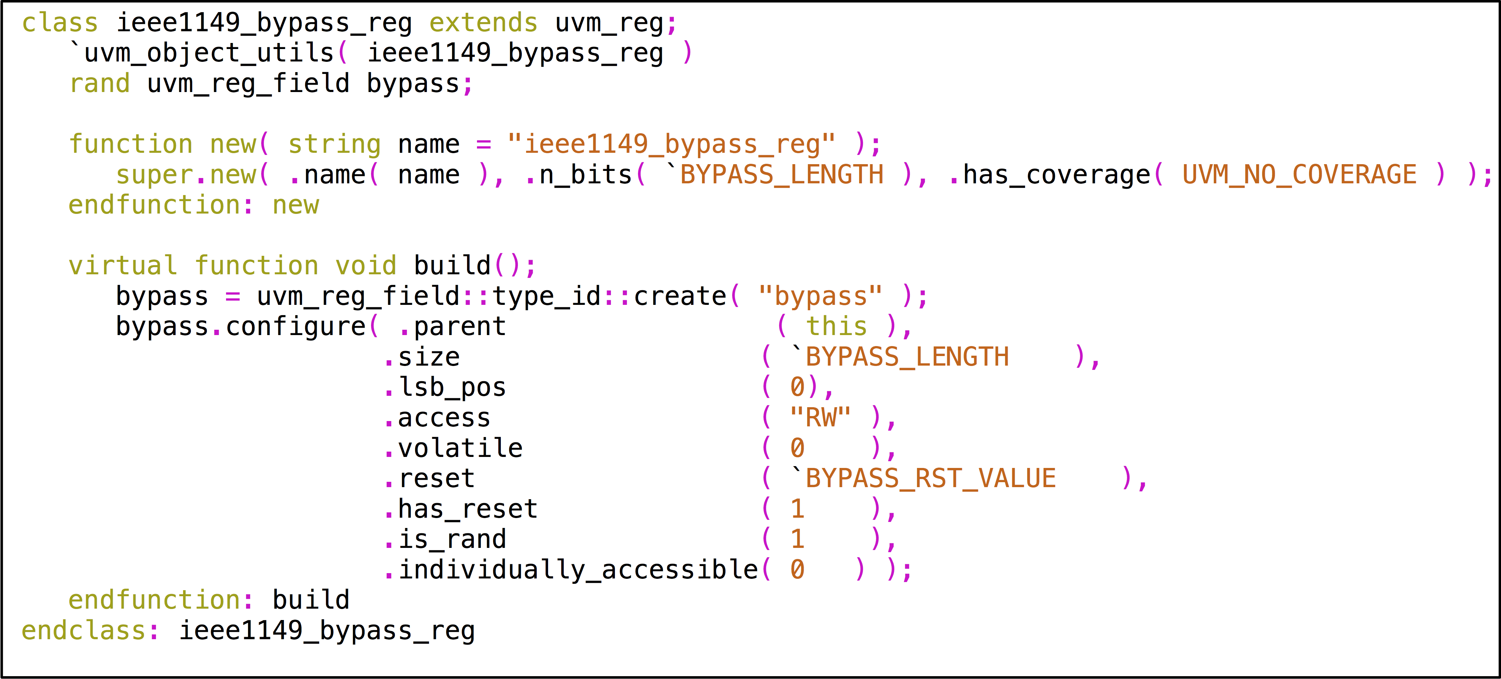
Figure 18. DFT TDR definition example

dft_tdr_transaction Class and bus_reg_ext Class
bus_reg_ext class is used for sending golden value to jtag_driver when doing register read or write in RAL. dft_tdr_adpter colons the extension information to the handle of extension in dft_tdr_transaction in bus2reg direction.
Fig. 19 and Fig. 20 show all properties of dft_tdr_transaction and bus_reg_ext class.
read_not_write indicates current register operation is a UVM_READ or UVM_WRITE type.
address is the encoded TDR address.
If current register access kind is UVM_WRITE, dft_tdr_adapter shift write data to wr_data_q. If current register access kind is UVM_READ, dft_tdr_adapter shift the default of the register to wr_data_q.
extension is an object of bus_reg_ext class, which is used to transfer the side information for TDO pad checking in RAL.
reg_length stores current register’s length.
In bus2reg direction, if current register access kind is UVM_WRITE, dft_tdr_adapter returns data in wr_data_q else returns rd_data_q.
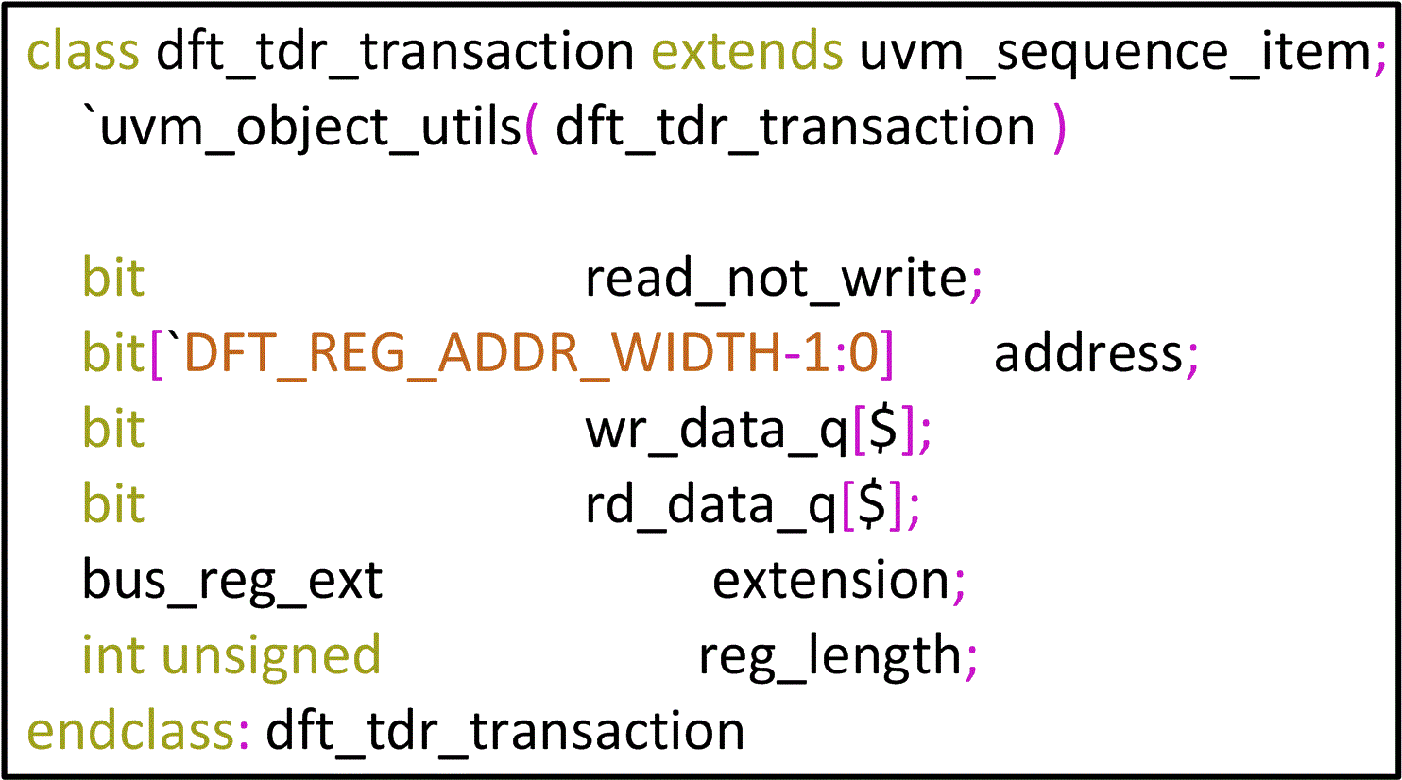
Figure 19. dft_tdr_transaction properties definition

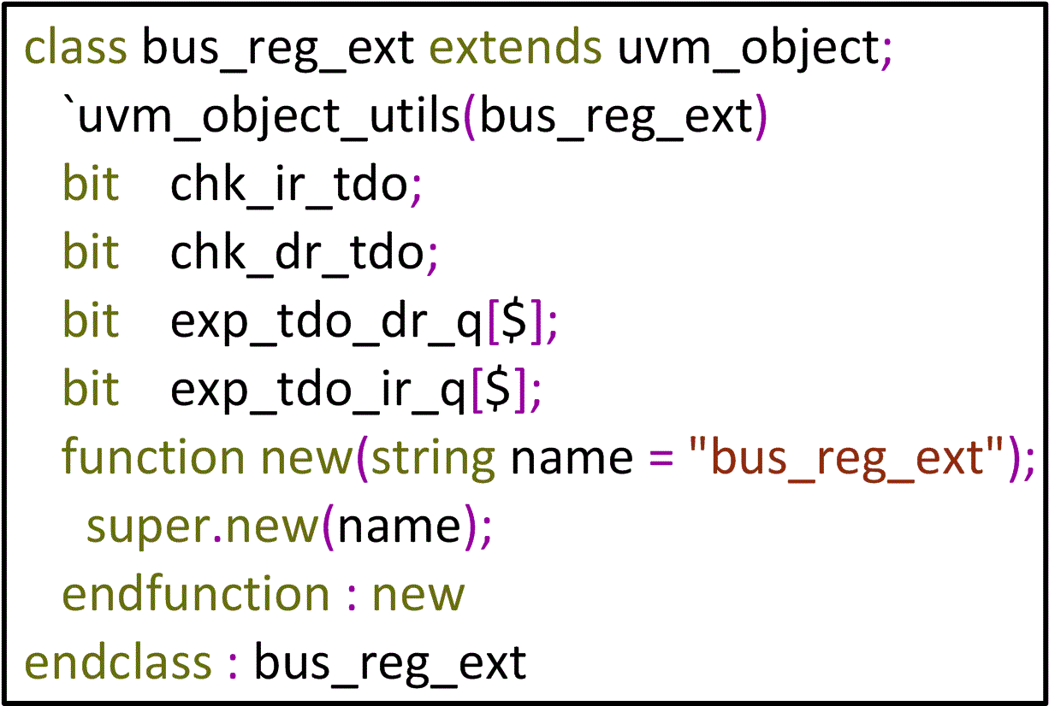
Figure 20. bus_reg_ext properties definition

IV. STIL Test Pattern Verification
In order to verify the content and behaviours of the generated STIL file, we can use STIL VerifyTM to generate a Verilog test bench and re-run simulation before delivering to ATE test engineers. The STIL file is verified if the simulation passes.
STIL VerifyTM is a free verification utility provided by Mentor Graphics for checking the conformity of STIL files, which ensures that STIL files are syntactically correct, and features a Verilog test bench that allows EDA (Electronic Design Automation) and ATE tool developers to run and display STIL content in any Verilog simulator taking STIL file and DUT as input [3].

V. Discussion
In Figure 1, pad_agent is mostly a physical layer agent that only toggles and samples pads directed by pad_rw_transactions, and has no knowledge about interface protocols, although it groups pads based on their interface protocols. If needed, the user can implement an upper layer agent to convert protocol-related transactions to pad_info_transactions and pass them down to pad_agent. Give an example.
For the sake of simplification, this paper focuses on describing how to build a verification environment that can convert UVM tests to test patterns for ATE test during simulation, and the common components such as coverage collectors and scoreboards are not shown, the user can easily implement them using transactions coming from jtag_monitor, dft_tdr_monitor and pad_monitor. Give an example.
Because we enforce every pad drive and sample should be done by a driver except for reference clock pads and each driver passes STIL information to the STIL generator whenever it drivers and samples a pad, the generated STIL pattern is functionally equivalent to its corresponding UVM test. Coverage statistics, which is gathered from coverage collectors to rank a UVM test, is also used to rate the generaged STIL pattern.

VI. Conclusion
This UVM-based DFT environment can be easily adopted in most projects for DFT function verification by overriding dft_env_configuration, grouping pads as shown in Section B, and defining related interfaces.
By modifying the call_stil_gen () method in each driver to transfer pad toggle and measurement information to the format of the other test language required, this environment could also generate other format patterns ATE needs, not just the STIL format.
Using this method, it saves usually a team’s work to translate DFT function tests to STIL patterns in a project, and more important, it avoids errors introduced in the muanul translation process to save turnaround debug efforts.
The approach to lift TDR in RAL is also a general way and can be applied in most projects by modelling related dft_tdr_network and overriding dft_tdr_trans_to_jtag_trans_sequence. And it makes it easy to migrate UVM tests developing from this UVM-based DFT verification environment among verification environments and tests from block to system levels.
This UVM-based DFT environment works correctly in an experiment project and the generated STIL test pattern files pass simulation using STIL VerifyTM, which indicates it could be applied in real projects.
The next step is to use this environment in real projects and validate it in post-silicon debug.

References
[1] Stuart Sutherland and Tom Fitzpatrick, UVM Rapid Adoption: A Practical Subset of UVM, Section 3.7.4, 21,
http://events.dvcon.org/events/proceedings.aspx?id=180-12
[2] Mentor Graphics, Online UVM Cookbook, Section Sequences/Layering, 302–307,
http://verificationacademy.com/cookbook
[3] Mentor Graphics, https://www.mentor.com/products/silicon-yield/getting_started_stil.

